Name Date
Pre-Course

Pre-Course Test
Tell whether the two fractions form a proportion.
Answers
1.
2.
3.
4.
5.
6.
7. See left.
8. See left.
9.
10.
11.
12.
13.
14.
15.
16.
17.
18.
19.
20.

1. 2. 3.
4. You buy a sweater that is discounted 25%. The original price of the sweater is $40. What is the price of the sweater after the discount?

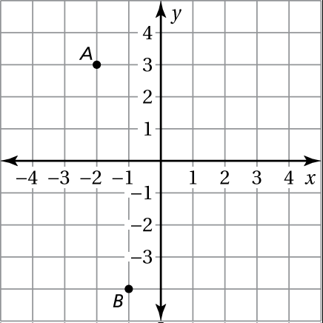
Find the coordinates of the point.
5. A 6. B
Plot the ordered pair.
7. 8.

Simplify the expression.
9. 10.
11. 12.
13. 14.
15. 16.

17. 18.

19. 20.
Chapter
X
Pre-Course

Pre-Course Test (continued)
Solve the equation, if possible.
Answers
21.
22.
23.
24.
25.
26.
27.
28.
29.
30.

21.
22.
23.
Find the side length of the square.
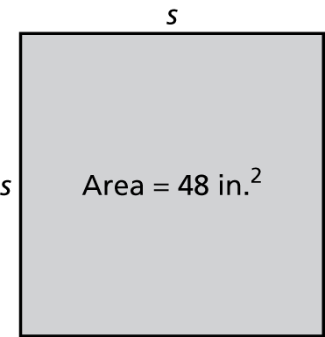
24.
Write the fraction as a decimal.
25. 26.

27. Find the slope and y-intercept of the graph of
Simplify the expression.
28. 29. 30.

